Physical Layer and MAC,Network Security ,Link management
Physical Layer and Mobile Computing
Wired Networks: Utilize physical cables (like Ethernet) to connect devices. They are known for stable connections and high speeds, especially in Local Area Networks (LANs).

Optical Networks: Use fiber optic cables to transmit data as light signals. These are crucial for high-speed, long-distance communication, such as in backbone internet infrastructure.

Wireless Networks: Include technologies like Wi-Fi, Bluetooth, and infrared. They enable mobility and ease of use but are subject to interference and signal degradation over distance.
Mobile and wireless: This is the most interesting case. No cable restricts the user, who can roam between different wireless networks. Most technologies discussed in this book deal with this type of device and the networks supporting them. Today’s most successful example forthis categoryisGSMwithmorethan800millionusers.

Radio Frequency (RF) Spectrum: Cellular networks operate on various frequency bands, with each band providing different characteristics like range and data capacity. The RF spectrum is divided into channels that are assigned to different users or data streams.

Base Stations and Cells: The cellular network is divided into small geographic areas called cells, each served by a base station. The base station communicates with mobile devices using radio signals, and manages the allocation of frequencies and resources.

Multiple Access Methods: Techniques like Frequency Division Multiple Access (FDMA), Time Division Multiple Access (TDMA), Code Division Multiple Access (CDMA), and Orthogonal Frequency Division Multiple Access (OFDMA) allow multiple users to share the same spectrum efficiently.

• Physical Layer :
1.The lowest layer in the OSI (Open Systems Interconnection) model.
2.Deals with the physical connection between devices, including the hardware and transmission media (like cables, fiber optics, and wireless signals).
3.Responsible for the transmission and reception of raw bitstreams over a physical medium.

MAC Layer (Media Access Control):

A sublayer of the Data Link Layer in the OSI model.
Responsible for controlling how devices on a network gain access to the medium and permission to transmit data.
Manages protocol access to the physical network medium, ensuring data integrity and addressing in a network environment (such as MAC addresses in Ethernet).

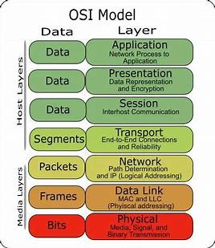

Networking (Network Layer):

The third layer in the OSI model.
Responsible for routing, forwarding, and addressing packets across different networks.
Manages logical addressing (such as IP addresses), data routing, packet forwarding, and error handling.

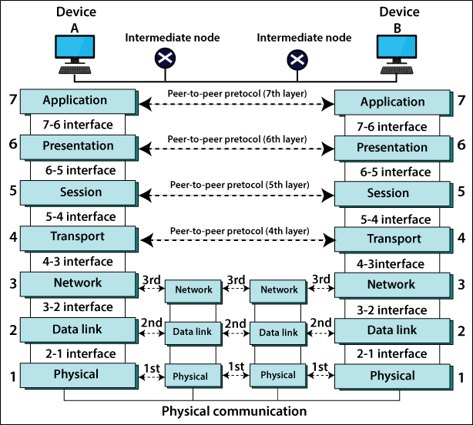

7 LAYER DEVICE NETWORK FIG

Security:
A critical aspect that spans across multiple layers of the OSI model, especially the Application, Transport, Network, and Data Link layers.
Involves measures to protect data, resources, and communications from unauthorized access, attacks, and breaches.
Includes aspects like encryption, authentication, secure protocols (like SSL/TLS), firewalls, intrusion detection/prevention systems (IDS/IPS), and secure network design.

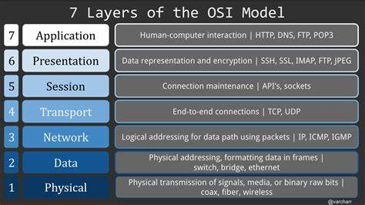

Unicast(local area) | Broadcast(www) | Multicast(metro)
A communication where a message is sent from one sender to one receiver. | A communication where a message is sent from one sender to all receivers. | A communication where a message is sent from one sender to a group of receivers

DNS (Domain Name System)
IP address, just like every home has a unique address for sending direct mail. 104.26.10.228 is an IP address consisting of four sets of numbers extending from 0 to 255 separated by a period.

POP3 (Post Office Protocol 3) and IMAP (Internet Message Access Protocol) both are MAA (Message accessing agent)

SSH(Secure Shell) Keys:1.Public key – Everyone can see it, no need to protect it. 2.Private key – Stays in computer, must be protected.
Internet Message Access Protocol (IMAP) and Secure Sockets Layer (SSL) is a digital security feature that enables an encrypted connection between a website and a browser.

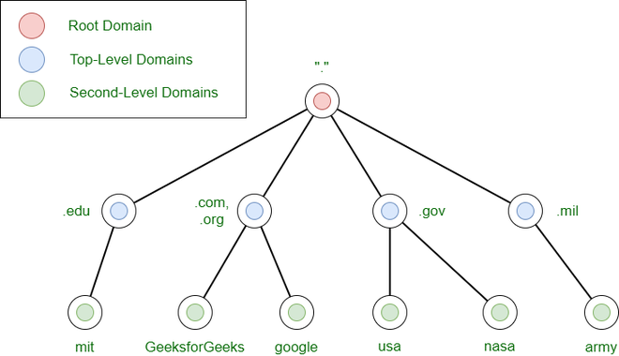

User Datagram Protocol (UDP) is a Transport Layer protocol. UDP is a part of the Internet Protocol suite, referred to as UDP/IP
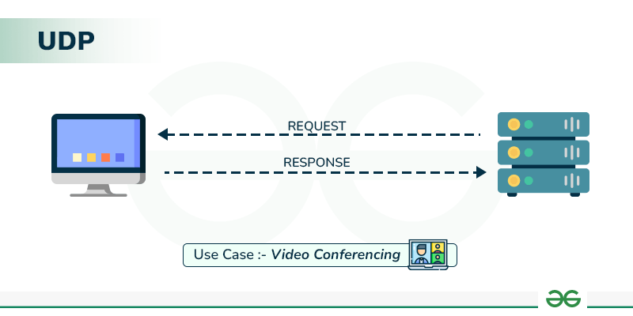

ICMP stands for Internet Control Message Protocol and IGMP stands for Internet Group Message Protocol.
IGMP is employed to form a group of hosts.
ICMP is employed to send error messages and operational data indicating by hosts.
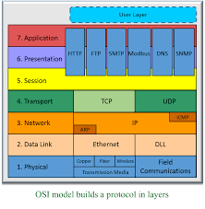

Security in Mobile Computing And link Management
Security in mobile computing is crucial due to the inherent vulnerabilities of wireless communication and the potential for device loss or theft. Security measures include:

Encryption: Securing data transmission with protocols like WPA3 for Wi-Fi, and encryption of data on devices.
Authentication: Ensuring that only authorized users and devices can access the network, often using multi-factor authentication.
Secure Communication Protocols: Using secure protocols like HTTPS, VPNs, and SSL/TLS to protect data in transit.
Mobile Device Management (MDM): Solutions that help secure, monitor, and manage mobile devices in an organization.
Anti-malware and Antivirus Software: Protecting devices from malicious software.

Malware is malicious software and refers to any software that is designed to cause harm to computer systems, networks, or users. Malware can take many forms. Individuals and organizations need to be aware of the different types of malware and take steps to protect their systems
1. DOS Attack is a denial of service attack, in this attack a computer sends a massive amount of traffic to a victim’s computer and shuts it down. Dos attack is an online attack that is used to make the website unavailable for its users when done on a website. This attack makes the server of a website that is connected to the internet by sending a large number of traffic to it.

- DDOS Attack means distributed denial of service in this attack dos attacks are done from many different locations using many systems.

Opera:Faster, safer and smarter than default browsers. Opera Browser is fully-featured for privacy, security, and everything you do online.
Free VPN for mobile and computer
A free browser VPN is built into Opera Browser for mobile and computer. No add-ons. Browse with enhanced online privacy using Opera.

Mozilla/crome:Get the not-for-profit backed web browser on Windows, Mac or Linux. Firefox is a free and customizable browser that offers fast browsing speed and privacy protection.

Browse in Incognito mode - Computer - Google Chrome Help
Incognito mode runs in a separate window from your normal Chrome windows.
If you have an Incognito window open and you open another one, your private browsing session will continue in the new window. To exit Incognito mode, close all …
If you find a number next to the Incognito icon at the top right
Tor Browser for Android is the official mobile browser supported by The Tor Project, a nonprofit organization dedicated to advancing human rights and freedoms. Get privacy and free…

PC/mobile internet security software providers
Generated using AI
Bitdefender,AVG Technologies,McAfee Multidevice protection,
Malwarebytes,Avast,F-Secure,G Data CyberDefense,Trend Micro,Norton Antivirus,Secure VPN,Kaspersky™ Digital Security ,Trend Micro (IN) | Internet Security Antivirus - PC

Mobile security is safeguarding personal information stored on these devices and preventing unauthorized access or misuse. Mobile security includes practices like setting strong passwords or biometric locks, keeping device software updated, installing antivirus software, and being cautious when downloading apps or browsing the internet.

